**Screenshots:**



The above screenshot proves first class registration functionality.



The above screenshot proves second class registration functionality.



The above screenshot proves redundancy checking functionality.



The above screenshot proves third class registration functionality.

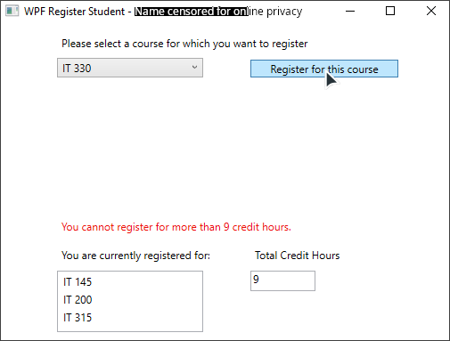

The above screenshot proves overdraw checking functionality.

**Code:**

using System.Windows;

namespace WPFRegisterStudent

{

**///** **<summary>**

**///** Interaction logic for MainWindow.xaml

**///** **</summary>**

public partial class MainWindow : Window

{

const int maxCreditHours = 9;

const int creditHourIncrement = 3;

int creditHours = 0;

Course choice;

Course[] courseArray =

{

new Course("IT 145"),

new Course("IT 200"),

new Course("IT 201"),

new Course("IT 270"),

new Course("IT 315"),

new Course("IT 328"),

new Course("IT 330"),

};

public MainWindow()

{

InitializeComponent();

}

private void Window_Loaded(object sender, RoutedEventArgs e)

{

foreach (var course in courseArray)

this.comboBox.Items.Add(course);

this.textBox.Text = "";

}

private void button_Click(object sender, RoutedEventArgs e)

{

choice = (Course)(this.comboBox.SelectedItem);

bool overdrawn = creditHours + creditHourIncrement > maxCreditHours;

bool redundant = choice.IsRegisteredAlready();

if (overdrawn || redundant)

{

string errorMessage;

if (overdrawn && redundant)

errorMessage = $"You cannot register for more than {maxCreditHours} credit hours, and you have \n" +

$"already registered for this {choice} course.";

else if (overdrawn)

errorMessage = $"You cannot register for more than {maxCreditHours} credit hours.";

else

errorMessage = $"You have already registered for this {choice} course.";

this.label3.Content = errorMessage;

return;

}

creditHours += creditHourIncrement;

choice.SetToRegistered();

this.textBox.Text = creditHours.ToString();

this.label3.Content = $"Registration confirmed for course {choice}.";

this.listBox.Items.Add(choice);

}

}

}